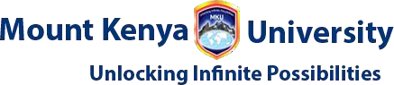
Student Name: RONNY MIRARA
Admission Number: BSCCS\2024\53811
Course: Bachelor of Science in Computer Science
Unit Code: BIT4139
Unit Name: ETHICAL HACKING AND COUNTER MEASURES
Lecturer Name: MR MICHAEL NYORO
Semester/Academic Year: SEM 2 YEAR 3

Contents
WEEK ONE 2
WEEK 2 5
WEEK 3 6
WEEK 4 7
TASK 8

Figure 1 Kali linux succesful installation 5
Figure 2 Initialization of isolated Host-Only network interface in VirtualBox. 6
Figure 3 IP Address 6
Figure 4 Validation of virtual network connectivity and successful host discovery. 7
Figure 5 Vulnerability assessment via Nmap Scripting Engine 8
Figure 6 social engineering foot printing in microsoft 9
Figure 7 DNS foot printing microsoft 9
Figure 8 SMNP Enumeration 11
Figure 9 LDAP Enumeration 11
Figure 10 SMTP Enumeration 12
Figure 11 Domain register and IP Address 13
Figure 12 IP Address of the server 14
Figure 13 Open Ports and Services 14
Figure 14 Leaked Credentials 14
Figure 15 successful identified a vulnerable input field 15

WEEK ONE
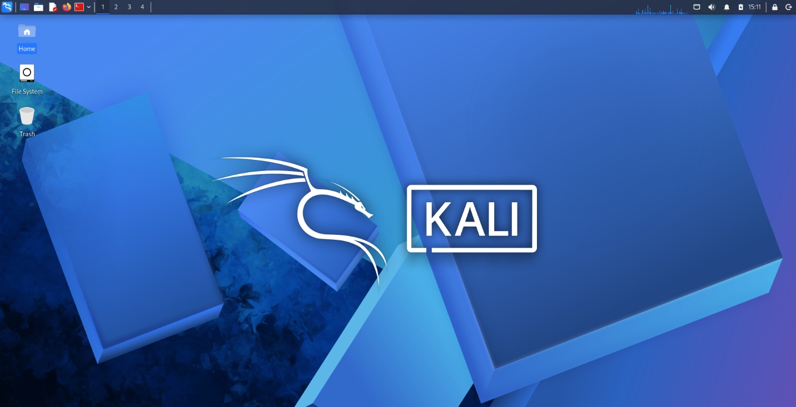
Figure 1 Kali linux succesful installation

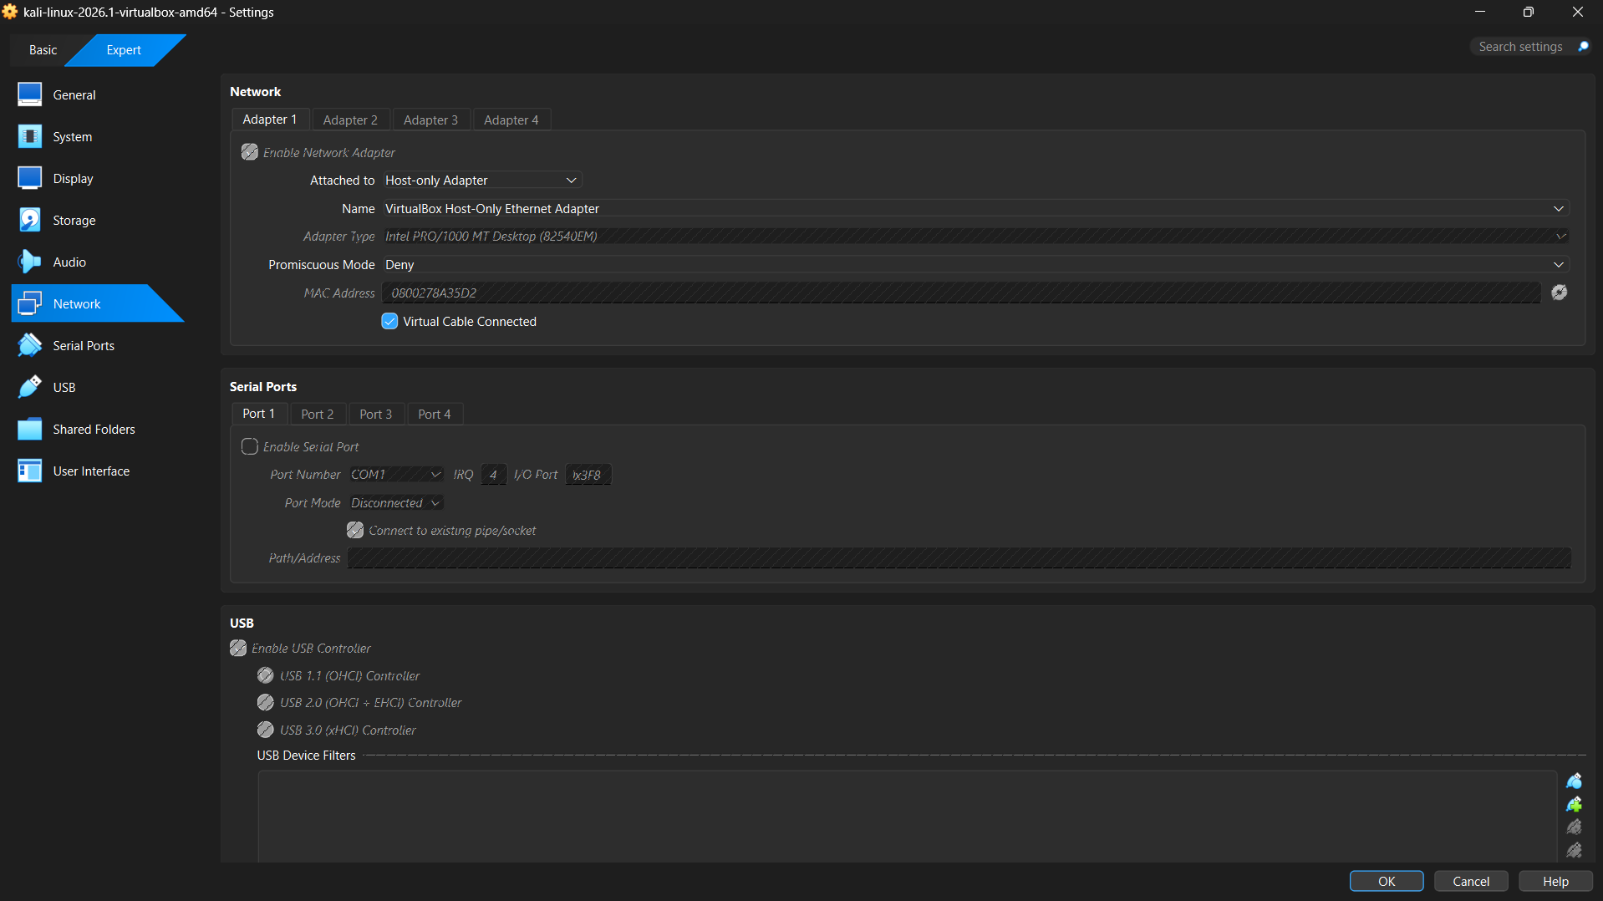
Figure 2 Initialization of isolated Host-Only network interface in VirtualBox.
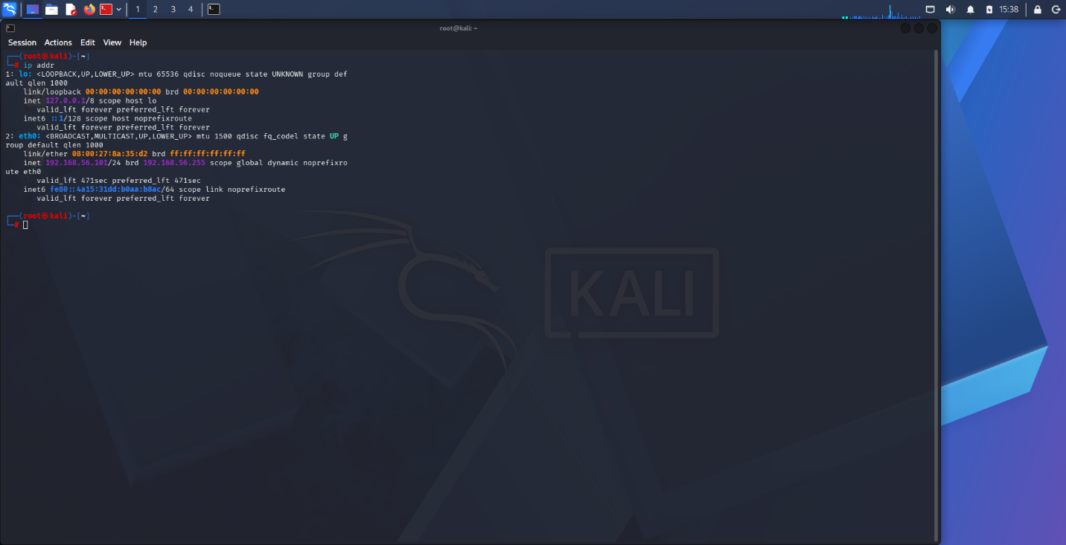
Figure 3 IP Address
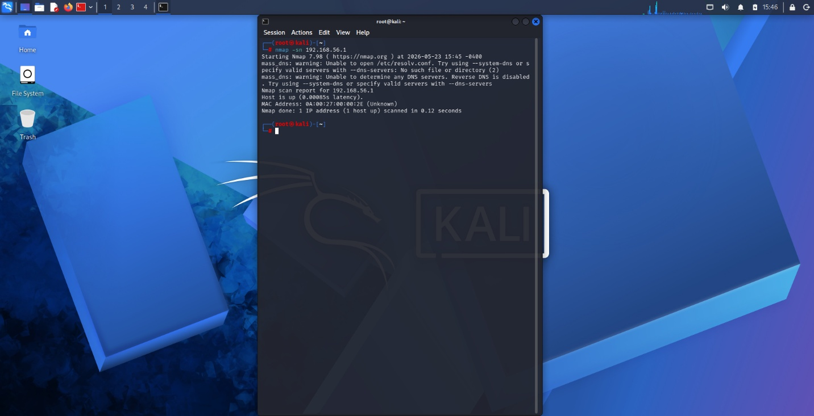
Figure 4 Validation of virtual network connectivity and successful host discovery.
STUDENT REFLECTION
I checked that my two machines were talking to each other by confirming my virtual machine had an assigned IP address. Then I used Nmap to ping the Windows host which proved it was visible and responsive within our private network

WEEK 2
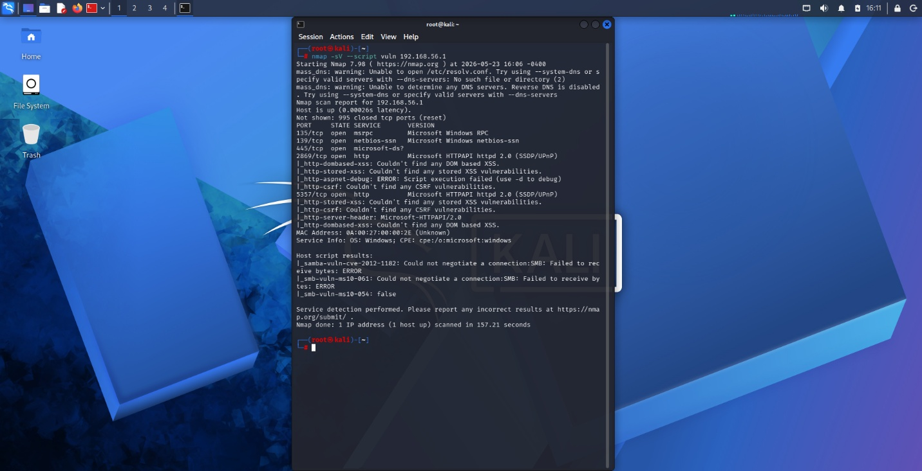
Figure 5 Vulnerability assessment via Nmap Scripting Engine
STUDENT REFLECTION
A vulnerability scan was executed against identified services to check for known security flaws. Results indicate that while services are reachable, the host firewall is actively filtering several threats.

WEEK 3
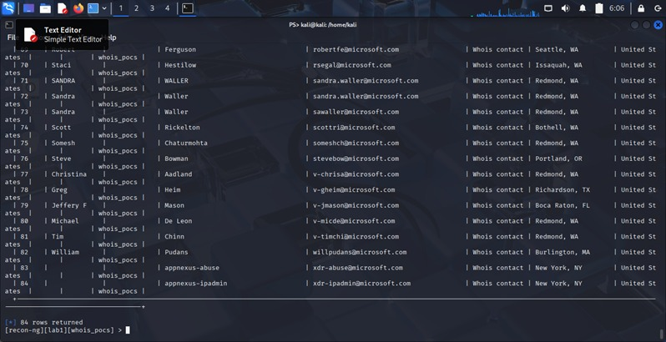
Figure 6 social engineering foot printing in microsoft
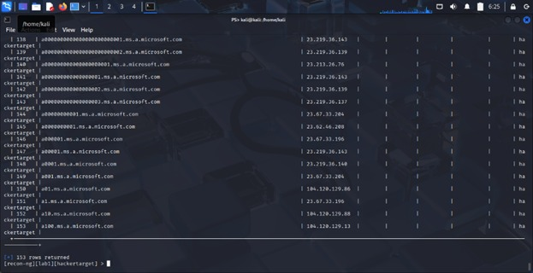
Figure 7 DNS foot printing microsoft
STUDENT REFLECTION
I was able to get information of the system without having to interact with the system . I was able to get the sub domains of the main domain

WEEK 4
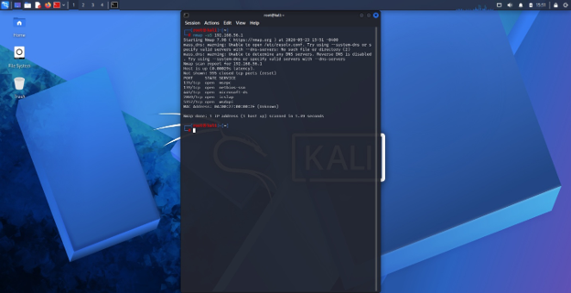
STUDENT REFLECTION
I scanned the target machine to see which ports were left open. By finding ports 135, 139, 445, 2869, and 5357, I created a map of the potential entry points

Week 5
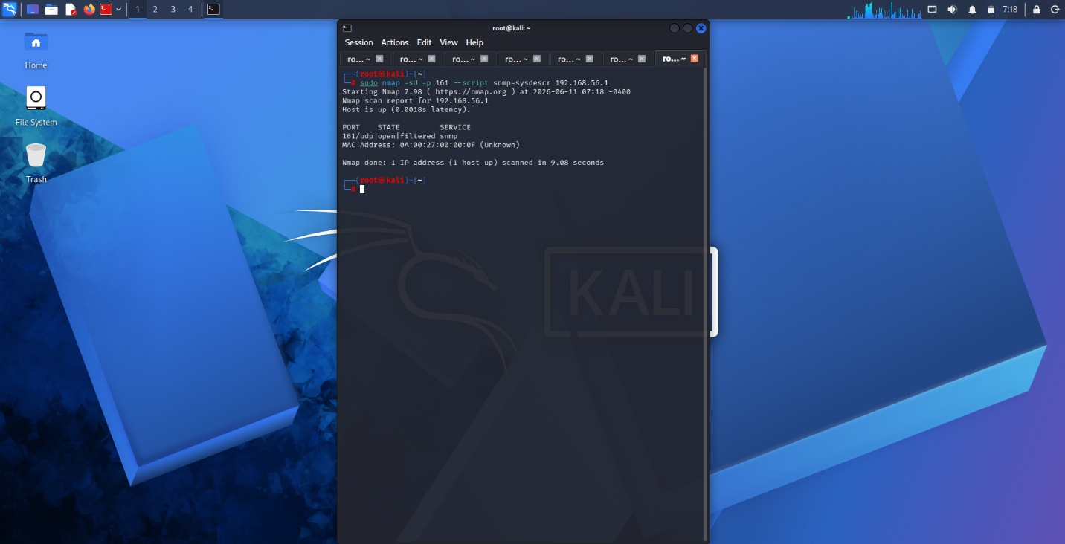
Figure 8 SMNP Enumeration
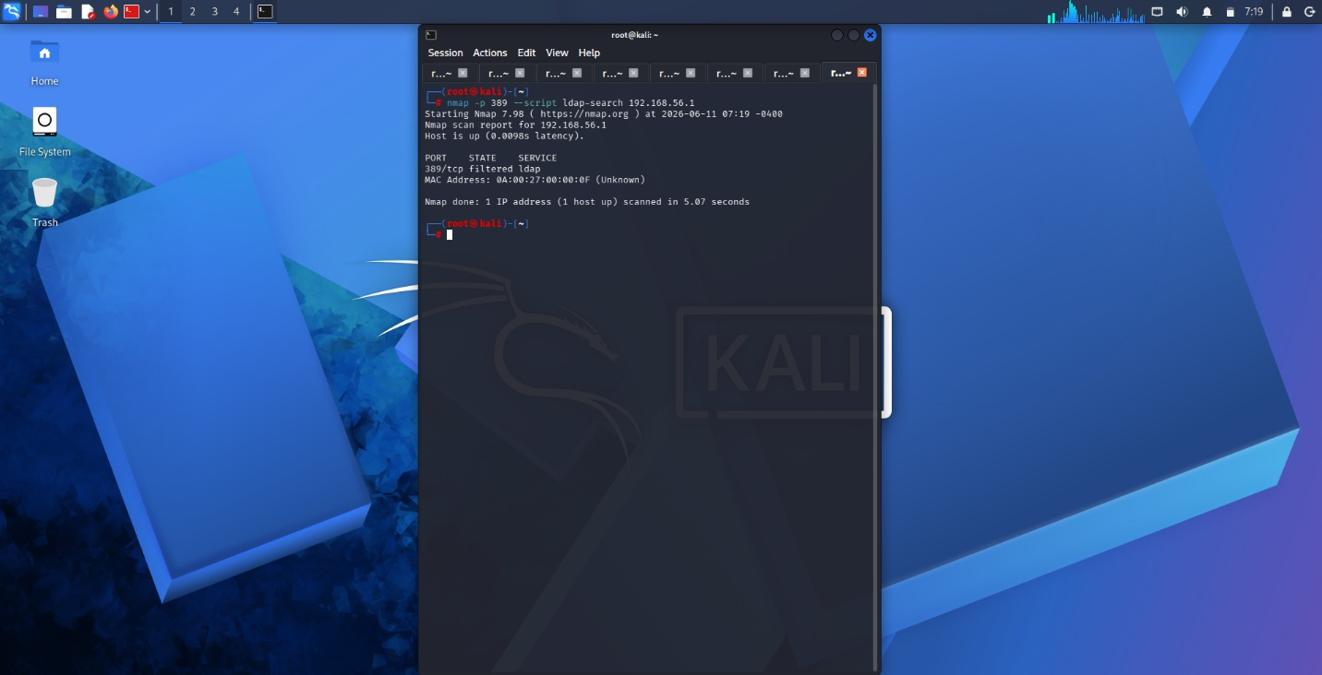
Figure 9 LDAP Enumeration
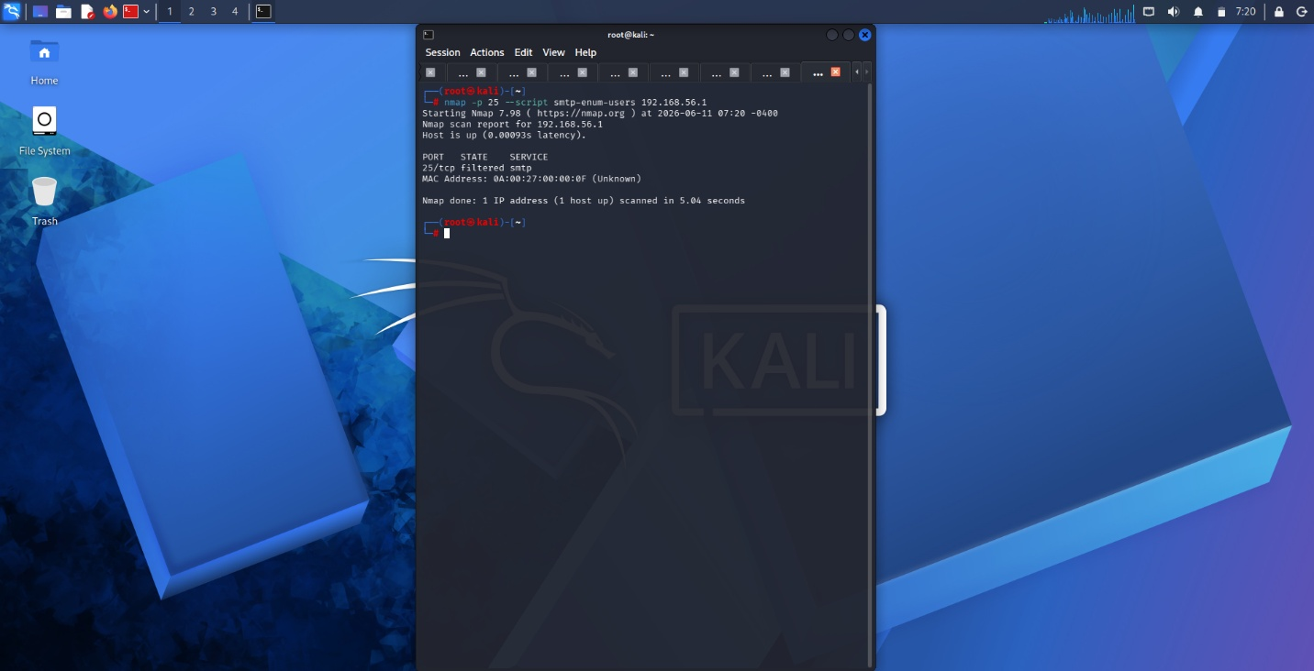
Figure 10 SMTP Enumeration
Performing SNMP enumeration showed me how a single misconfigured community string like public can leak deep system architecture data without needing a password. Investigating LDAP enumeration taught me the dangers of allowing 'anonymous binds' on a directory service. Seeing how an unauthenticated connection to TCP port 389 can allow a user to map out an entire active directory structure. Investigating LDAP enumeration taught me the dangers of allowing 'anonymous binds' on a directory service. Seeing how an unauthenticated connection to TCP port 389 can allow a user to map out an entire active directory structure. Testing SMTP enumeration opened my eyes to how default mail commands like VRFY and EXPN can be abused to map out valid corporate email addresses

TASK
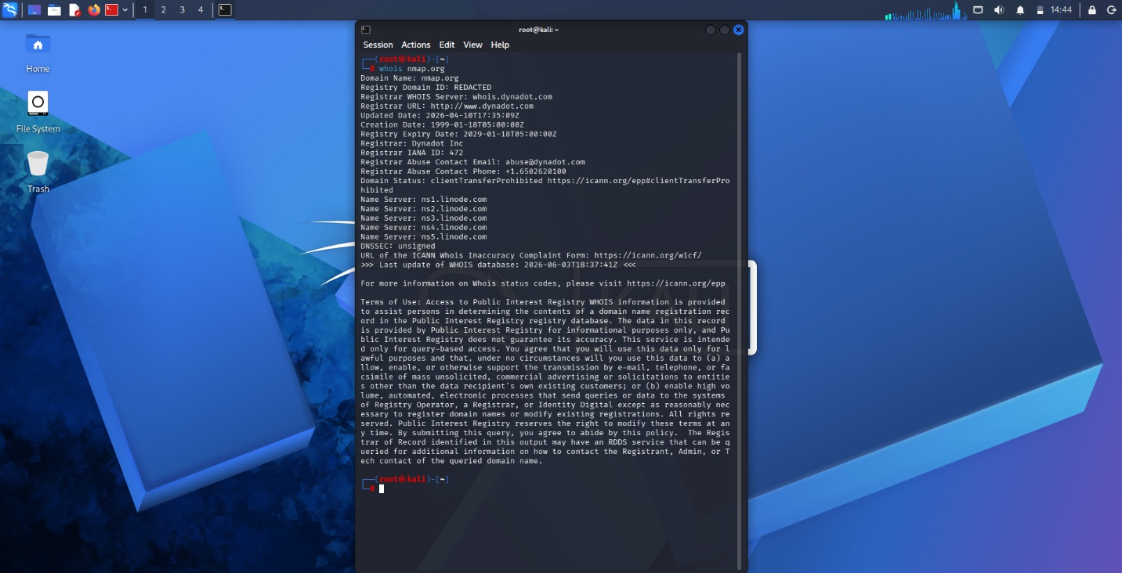
Figure 11 Domain register and IP Address
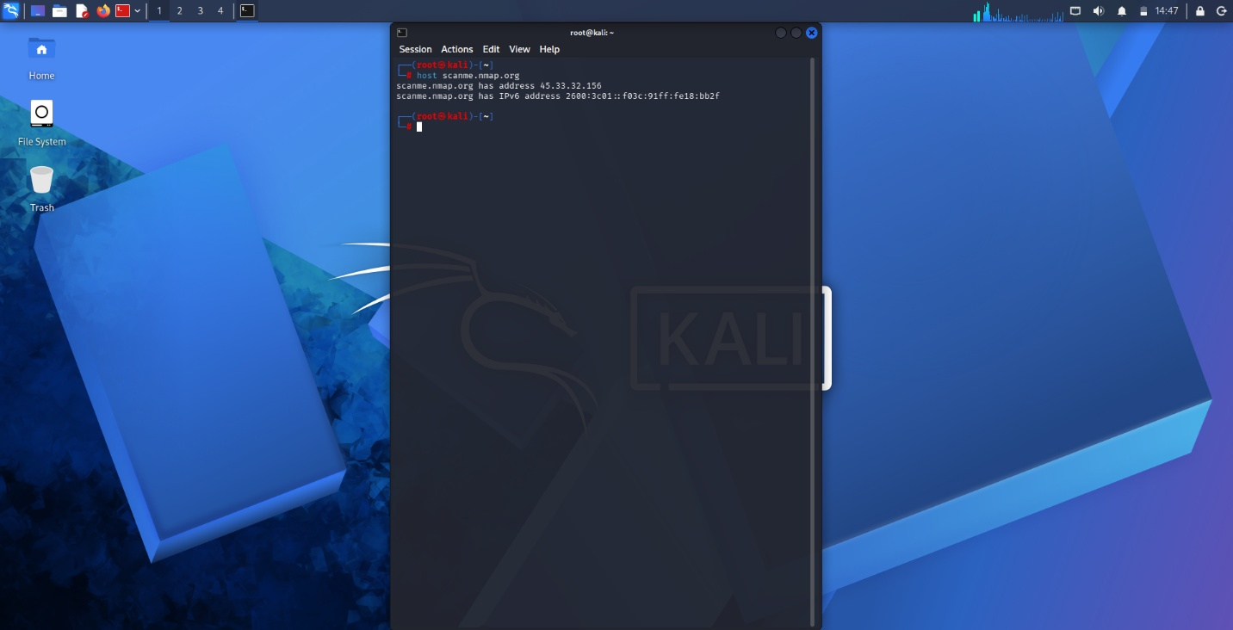
Figure 12 IP Address of the server
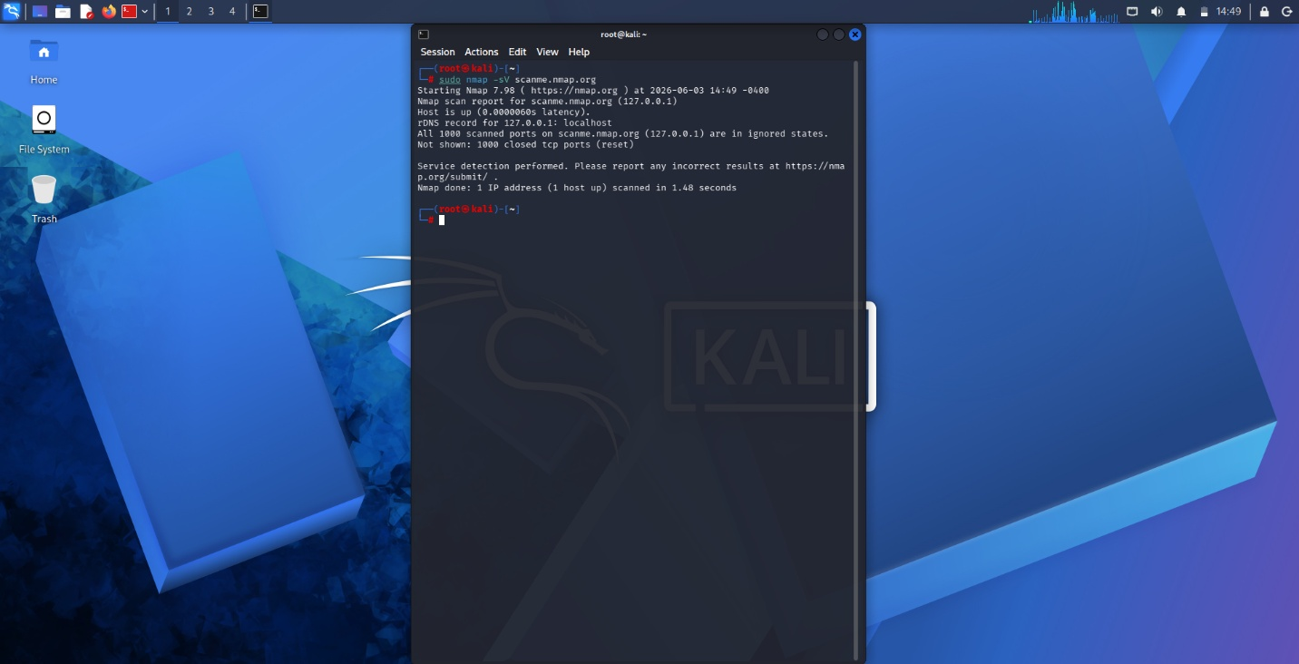
Figure 13 Open Ports and Services
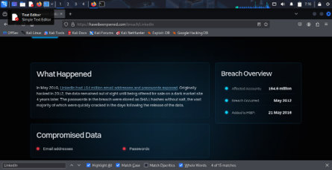
Figure 14 Leaked Credentials
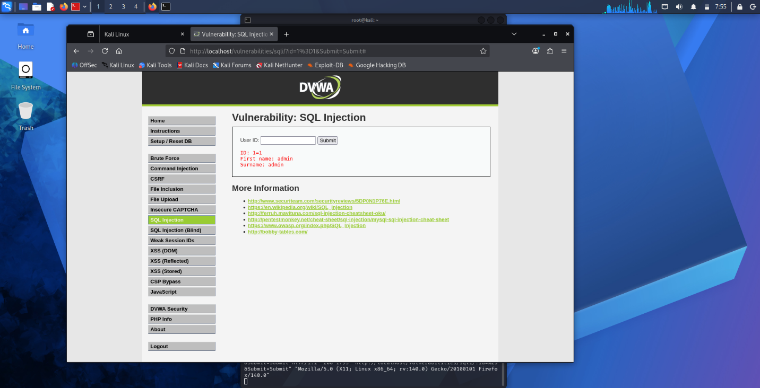
Figure 15 successful identified a vulnerable input field

STUDENT REFLECTION
Using nmap it enabled me to find open ports like port 80 and 21and detect the running services I also was able to attack the back end of a website and able to configure the allow myself to see the users that are using the said website their username and password used

